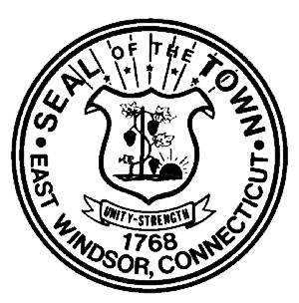

TOWN OF EAST WINDSOR

ASSESSOR’S OFFICE

Public Act 490 (PA 490) Classification – Grand List of October 1st

Dear Property Owner(s):

Pursuant to Connecticut General Statutes, please be advised that if you wish to apply for Farm Land classification you must file the PA 490 Application. The PA 490 Application (both sides) must be completed in full and returned to this office by December 30th to qualify.

The Farm Land Classification is personal to the particular owner who requests and receives such classification and shall not run with the land.

If the Farm Land Classification has been granted and one of the following changes
occur you must file a new application. They are: Change of Ownership/Change of
Acreage or Change of Use

Tillable land is used for harvesting crops of any kind such as hay, tobacco, or vegetables. Pasture land
is fenced and used for grazing animals. Keep in mind that simply cutting fields (brush hogging or hog mowing) does not constitute farming, nor does any agricultural endeavor that has not yet produced a viable crop. Also to be considered is the gross income derived from the land, nature and value of equipment used in connection with the farm operation, and the extent to which tracts, comprising the land, are contiguous.

Relative to the property listed above, please also provide the following:
- IRS Schedule F for year Prior to Current Grand List;
- Copy of licenses and permits issued by the Department of Agriculture; and
- Declaration of Personal Property for year Prior to Current Grand List showing all farming equipment used for the farming business.

An on-site inspection of the property listed above may be required in order to determine the extent to which the land is actually used for commercial farming. Please see the Statutes relating to farm land classification (Connecticut General Statutes §12-107a through 12-107e) enclosed herewith.

If you have any questions, please do not hesitate to contact this office.

Sincerely,
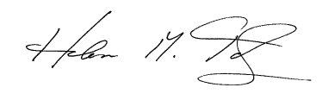
Helen M Totz, CCMA II
Assessor

11 Rye Street, Broad Brook, CT 06016-9553 Telephone (860) 623-8878
“This institution is an equal opportunity provider and employer”

