The Kentucky tornado disaster last month left many families devastated and displaced from their homes. Connecticut Lions are working to support **315** Kentucky families that will soon be housed in FEMA trailers.

We understand that the trailers furnished by FEMA are bare.

They need household items (new or gently used) as seen in

the list below.

It’s been reported they have enough clothes and food.

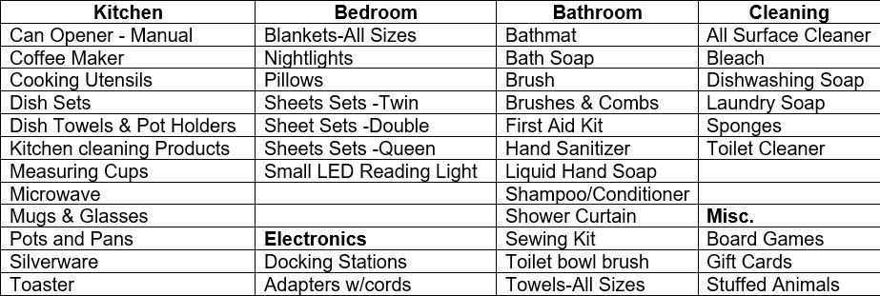

All items will be assembled for sorting and loading on February 11th and 12th to be transported to Paducah, KY. Please reach out to your local Lions Club if you would like to donate something to this cause. In East Windsor items may be brought to the Town Hall, 11 Rye Street, Broad Brook or Town Hall Annex, 25 School Street, East Windsor. Or call East Windsor Lion Barbara Sherman at 860-623-2081.

**THANK YOU!!!**