December 31, 2021

Good evening,

This is First Selectman Jason Bowsza reaching out to all residents of the Town of East Windsor.

We have received an initial supply of at-home COVID tests, although fewer than we had anticipated. We also have received a supply of N-95 masks. We will be distributing both on a first come/first served basis while supplies last on New Year’s Day at the Town Hall (11 Rye Street, Broad Brook), from 3pm to 6pm. If there are any tests still available after tomorrow’s distribution, they will be moved to the Police Station (25 School Street, East Windsor) and distributed twenty-four hours a day in the main lobby as needed and while supplies last.

Due to the reduced supply of tests provided, DPH has asked that tests be prioritized for high-risk individuals, to those who are showing symptoms, or to those who have had a close contact with someone who is COVID-positive.

Any East Windsor resident who meets any of those criteria can come and pick up a test while supplies last. Proof of residency will be requested prior to the distribution of tests or masks. This could be a driver’s license, or a photo ID and a recent bill.

If more tests are provided to the Town, I will provide updates concerning distribution to the public.
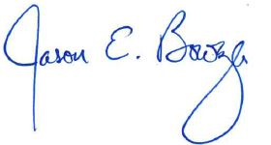
Sincerely,

Jason E. Bowsza
First Selectman

